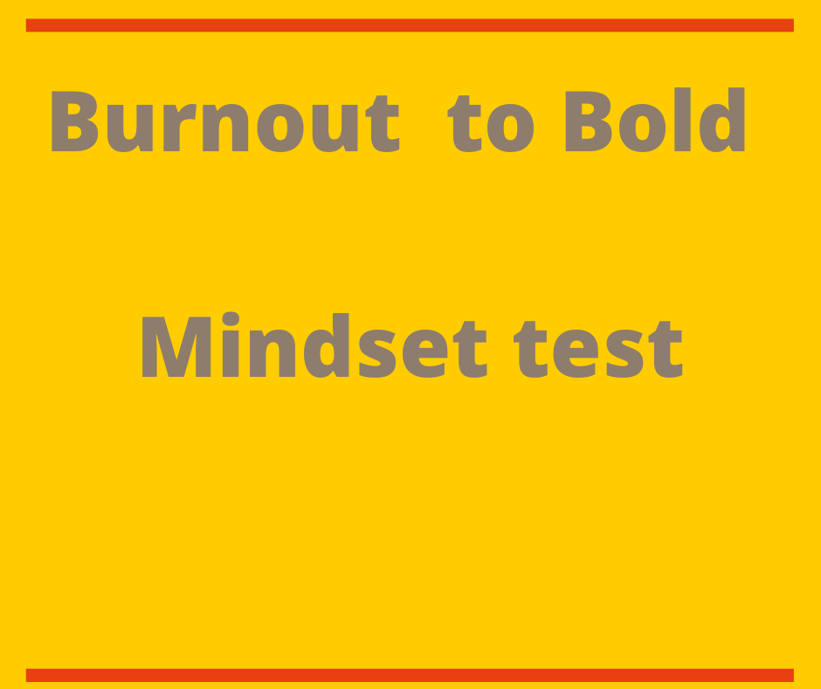

Mindset Test

Your Mindset is a set of beliefs that affects how you think, feel and behave, the key is not about ability, but your beliefs about your ability. There are two types of mindset: Fixed Mindset and Growth Mindset.

Take a look at the following questions and decide whether you mostly agree or mostly disagree with the statements.
Question | Agree | Disagree
1, Your intelligence is something that can not be altered?
2, You can learn new things but you can’t change how intelligent you are?
3, How ever intelligent you are,you can alway improve your intelligence?
4, You can always improve your levels of intelligence

This will help you to establish what type of mindset you have today, remember you can switch your mindset to a growth mindset it just takes practise.

If you agreed with Q’s 1 & 2, you have a fixed mindset, if you agreed with Q 3 & 4 you have a growth mindset. You can also use this tool to establish what type of mindset you have based on other areas of your life. Like your creativity, your health and wellbeing and so on. It's a quick and easy assessment tool to help you to make a positive change in your life.

Burnout to Bold by Marie Jenkins is part of Advance your Wellbeing Ltd
If you need help with Wellbeing; from consultancy to bespoke training packages or solutions visit us at www.advanceyourwellbeing.co.uk

